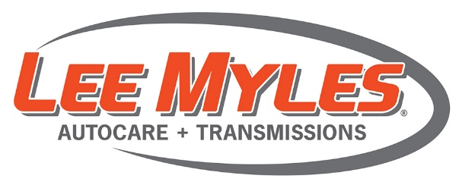
Brought to you by your neighborhood Lee Myles Auto Care & Transmissions
Walker Auto Care, Inc.
6714 Perkiomen Avenue Birdsboro, PA 19508
610-404-4227
ENTER FOR YOUR CHANCE TO WIN!
$100 GIFT CARD!
LOVE THIS RESTAURANT?
ENTER TO WIN A $100 GIFT CERTIFICATE TODAY!!
EASY TO ENTER – EASY TO WIN! VISIT OUR WEBSITE OR SCAN OUR QR CODE
WWW.LEEMYLES422.COM
CONTEST ENDS FEBRUARY 12TH, 2020
Contest rules listed on website

